**Project Report**

**Saranya Pandiaraj (015304497)**

***Data 230 Data Visualization***

**Department of Applied Data Science**

**San Jose State University**

**Section 11, Spring 2021**

Futuristic Airbnb – Exploring in London

**Table of Contents**

Project Details 2

Project Name 2

Project Goal 2

Project Deliverables 3

Project Abstract 4

Data Set Resources 4

References 4

**Project Report**

# Project Details

|  |  |
| --- | --- |
| **Name** | Saranya Pandiaraj |
| **Student ID** | 015304497 |
| **GitHub ID** | SaranyaPandiaraj |

# Project Name

Futuristic Airbnb – Exploring in London

# Project Goal

The main goal of this project is to design an Interactive dashboard using data visualization tools (Tableau) from the publicly available datasets.

# Project Deliverables

|  |  |  |  |  |  |  |
| --- | --- | --- | --- | --- | --- | --- |
| Sr No. | Deliverable  Name | Deliverable  Description | Start Date | End Date | Status | Notes |
| 1 | **Requirement Gathering** | Project Goals - What needs to be done? | 02/01/2021 | 02/02/2021 | Completed |  |
| 2 | **Data Set Exploration** | Identifying & Understanding the Data Sets | 02/03/2021 | 02/08/2021 | Completed |  |
| 3 | **Project Proposal** | Project Abstract – What is to be done? - Research questions | 02/09/2021 | 02/11/2021 | Completed |  |
| 4 | **Data Extraction & Clean-up** | Cleaning up unnecessary data from the dataset | 02/22/2021 | 02/28/2021 | Completed | Includes of Coding work |
| 5 | **Final Data Analysis** | Data Transformation  (Any Logics to be applied) | 02/22/2021 | 02/28/2021 | Completed | Includes of Coding work |
| 6 | **Data Visualizations**  **(Includes of Creating Stories & Dashboards)** | Listing Visualizations | 03/01/2021 | 04/10/2021 | Completed | Parallel Work on Visualization  (plus coding work) |
| Host Visualizations | 03/01/2021 | 04/15/2021 | Completed |
| Reviews Visualizations | 03/01/2021 | 04/20/2021 | Completed |
| 7 | **Outcomes** | Take Away from the dashboards | 04/01/2021 | 04/23/2021 | Completed |  |
| 8 | **Future Work** | Future Ideas to implement in the dashboards | 04/24/2021 | 04/26/2021 | Completed |  |
| 9 | **Presentation/**  **Project Report** | To create a PPT & Project Report to include abstract, diagrams, snapshots; etc; | 04/20/2021 | 05/05/2021 | Completed |  |

# Project Abstract

Airbnb is a vacation rental platform where the user can rent a home for tourism experiences. User can also list their properties in Airbnb for renting it out. Airbnb can see an exponential increase in the number of rentals listed on their platform every year. The platform has attracted more people with their home friendly services and hospitality. Thus, feels like staying in a home even on a vacation.

London is the most popular place having around 87000 listings as of December 16, 2020. Around 40% of their listings with the entire home types are being rented out to the tourists for more than 90 days term. On an average term, Airbnb guests stay for around an average of 4.5 nights in London.

The main purpose of this project is to analyze and visualize the Airbnb dataset. Our investigation will help us to determine the factors for the success of Airbnb business; places to explore for the hosts to expand the Airbnb business; covid impacts on Airbnb; listings managed by the hosts; Renting prices based on the accommodates; judging the host response rate; Visitor trends based on the reviews; forecasting/predicting the listing price over the time; availability frequency; etc. To visually analyze the data, we will be creating an interactive dashboard & stories using Tableau. This dashboard will be helpful for the user to find a better accommodation based on customer satisfaction & requirements. And, will also help in improving the Airbnb business based on certain factors in London.

# Data Set Resources

<https://www.kaggle.com/labdmitriy/airbnb>

<http://insideairbnb.com/get-the-data.html>

The Data Files used for this project is as below.

* **listings.csv**

This file contains about the Airbnb Host, listing and Property Information’s. It also contains about the reviews scores & availability details of the property.

* **reviews.csv**

This file contains about the review information of the property.

* **calendar.csv**

This file contains about the Property availability and its price information for the future year.

* **neighbourhoods.geojson**

This file contains the geographical features of the London neighbourhoods having the Airbnb listings



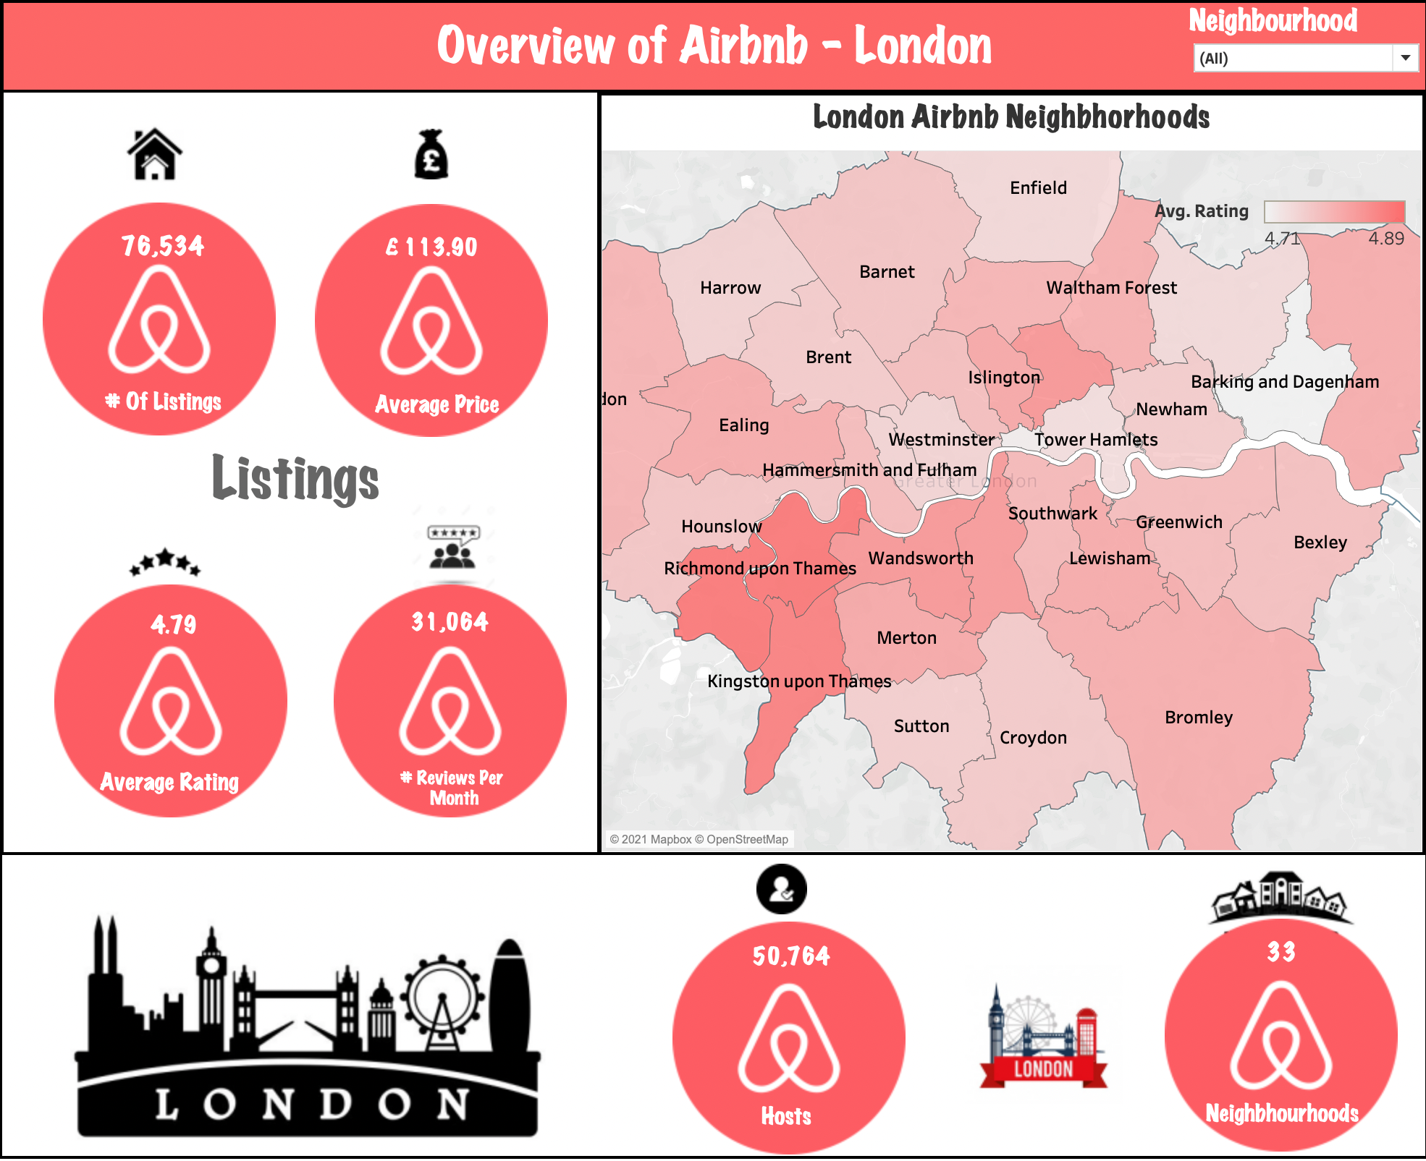



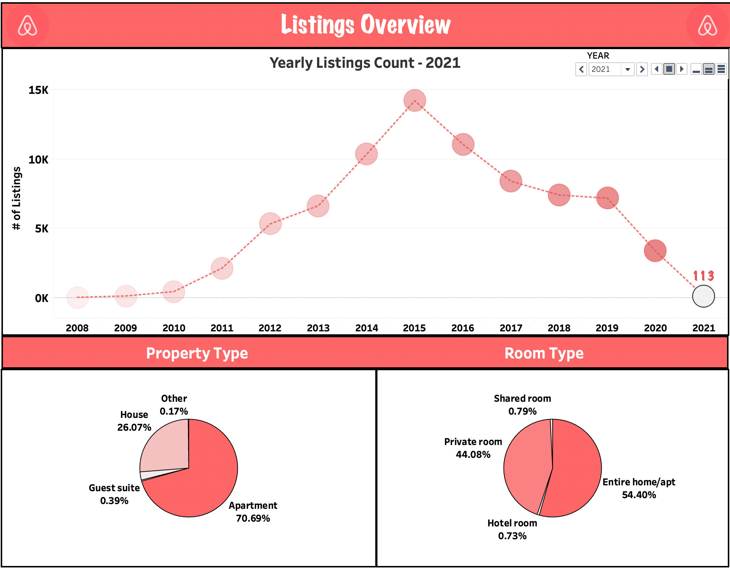

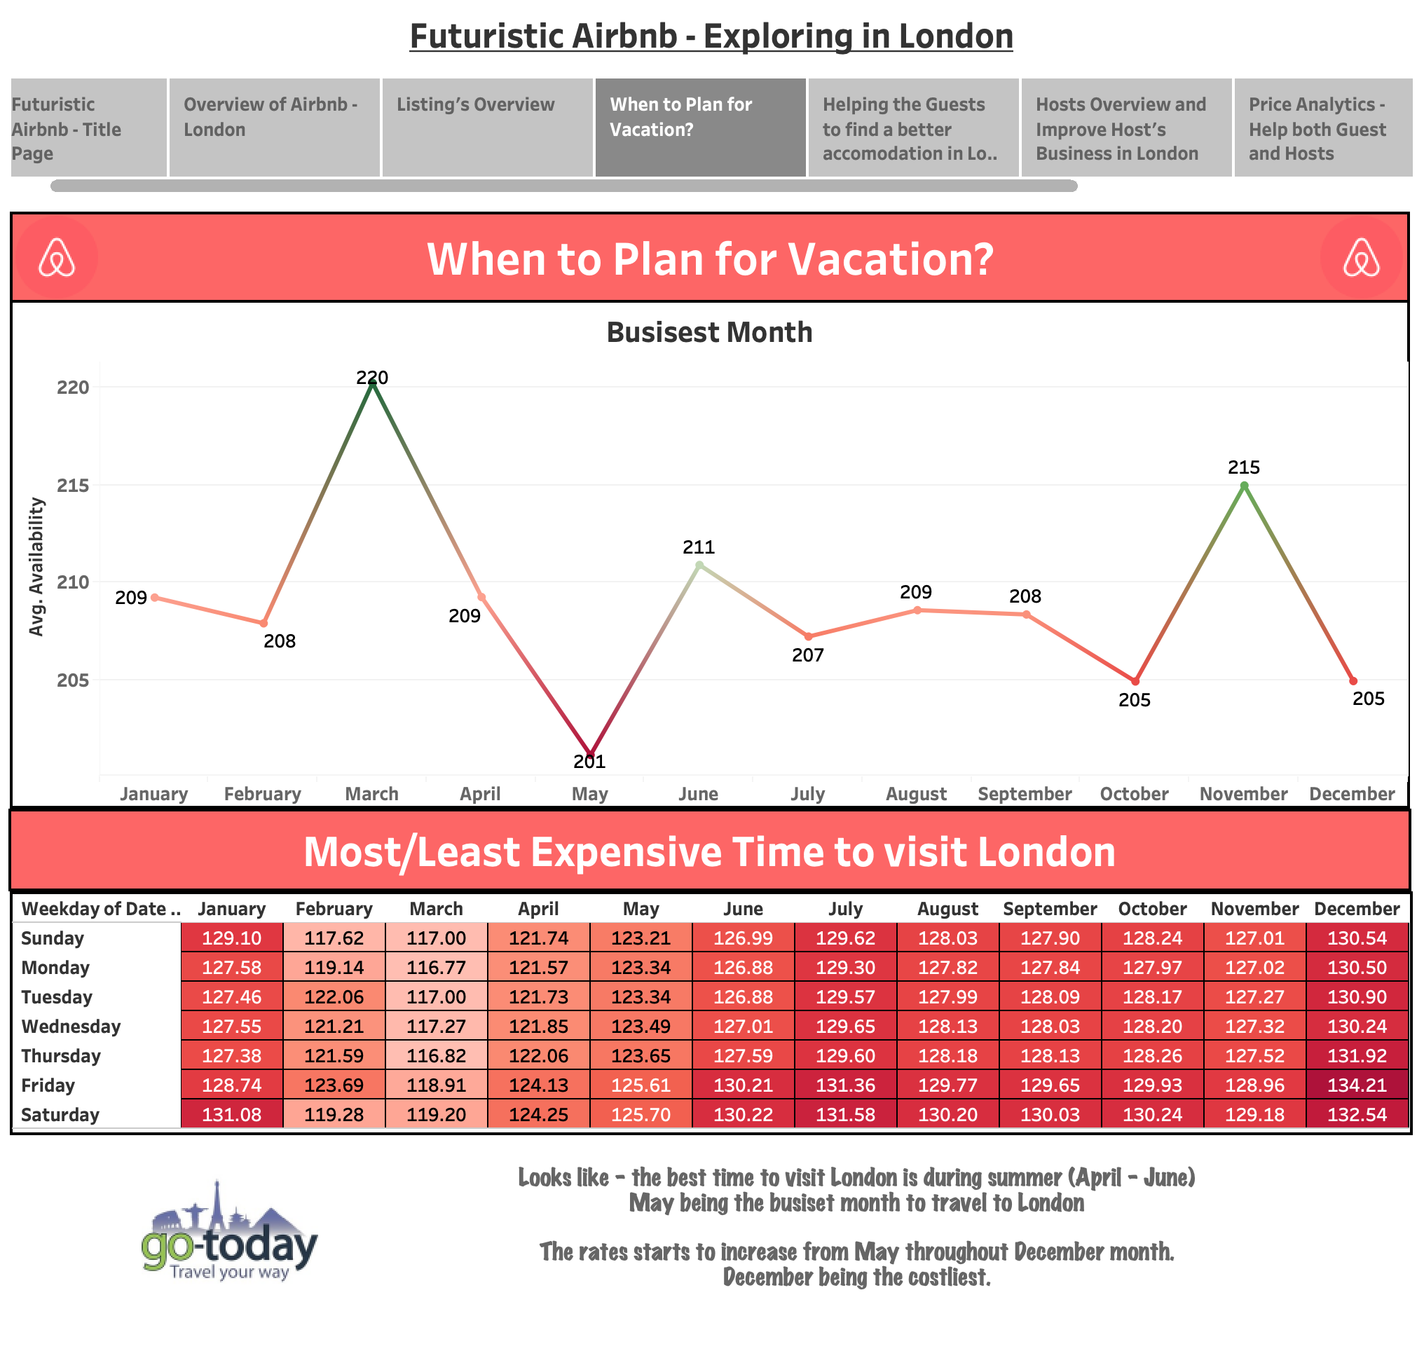



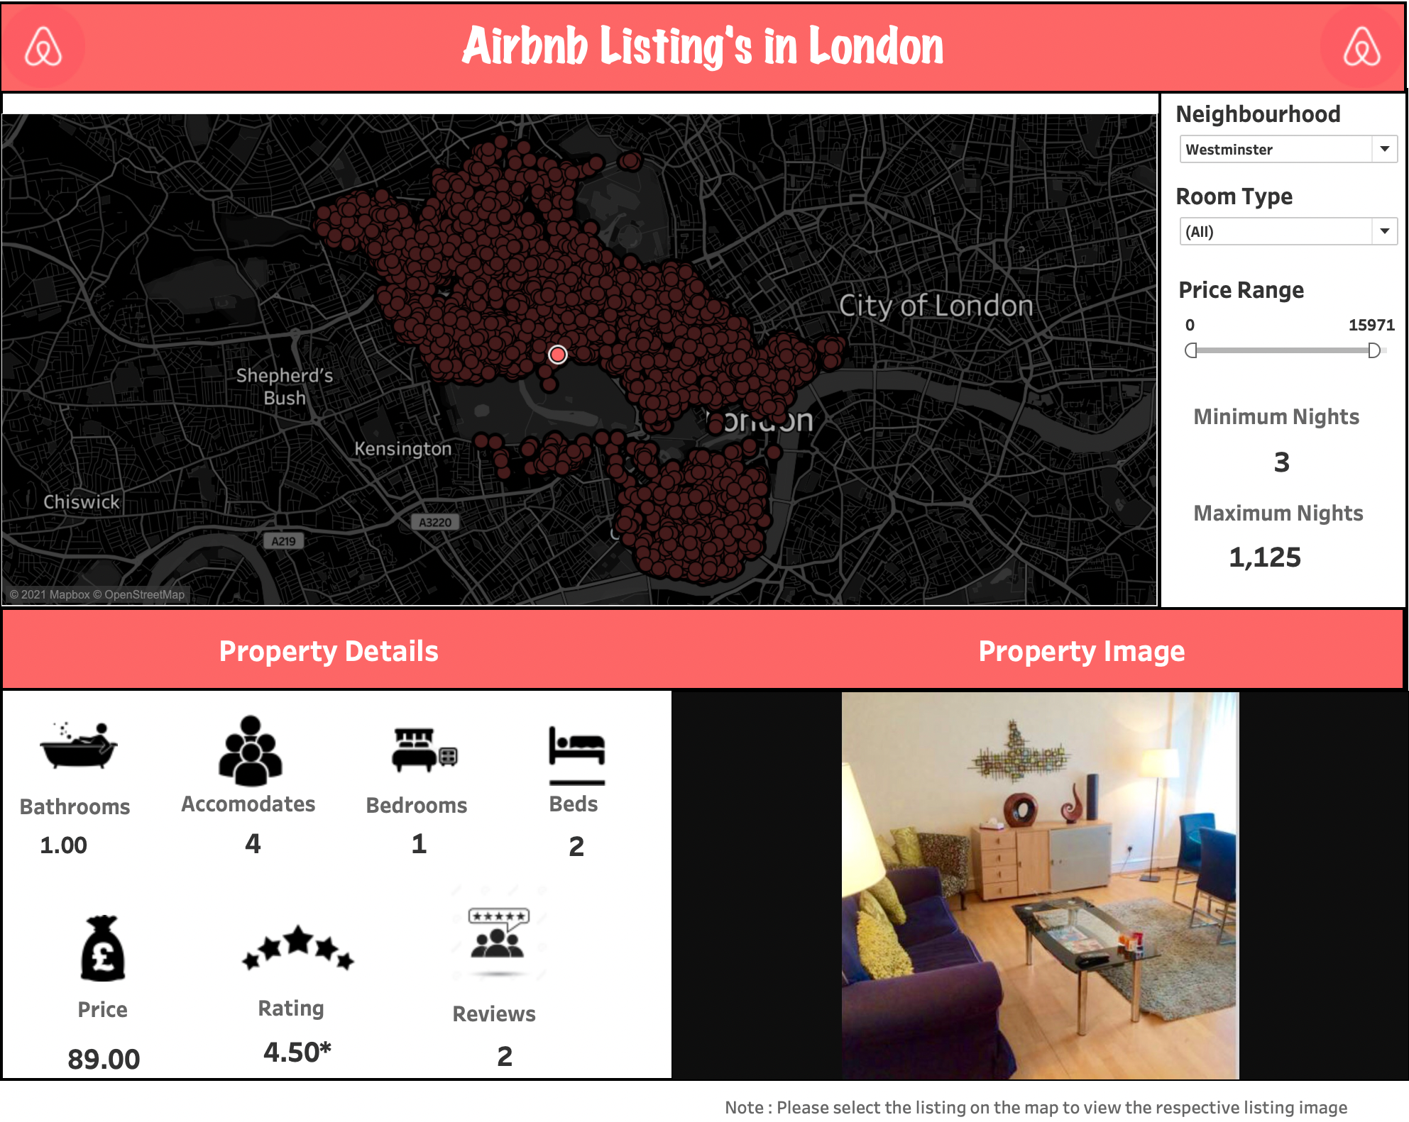



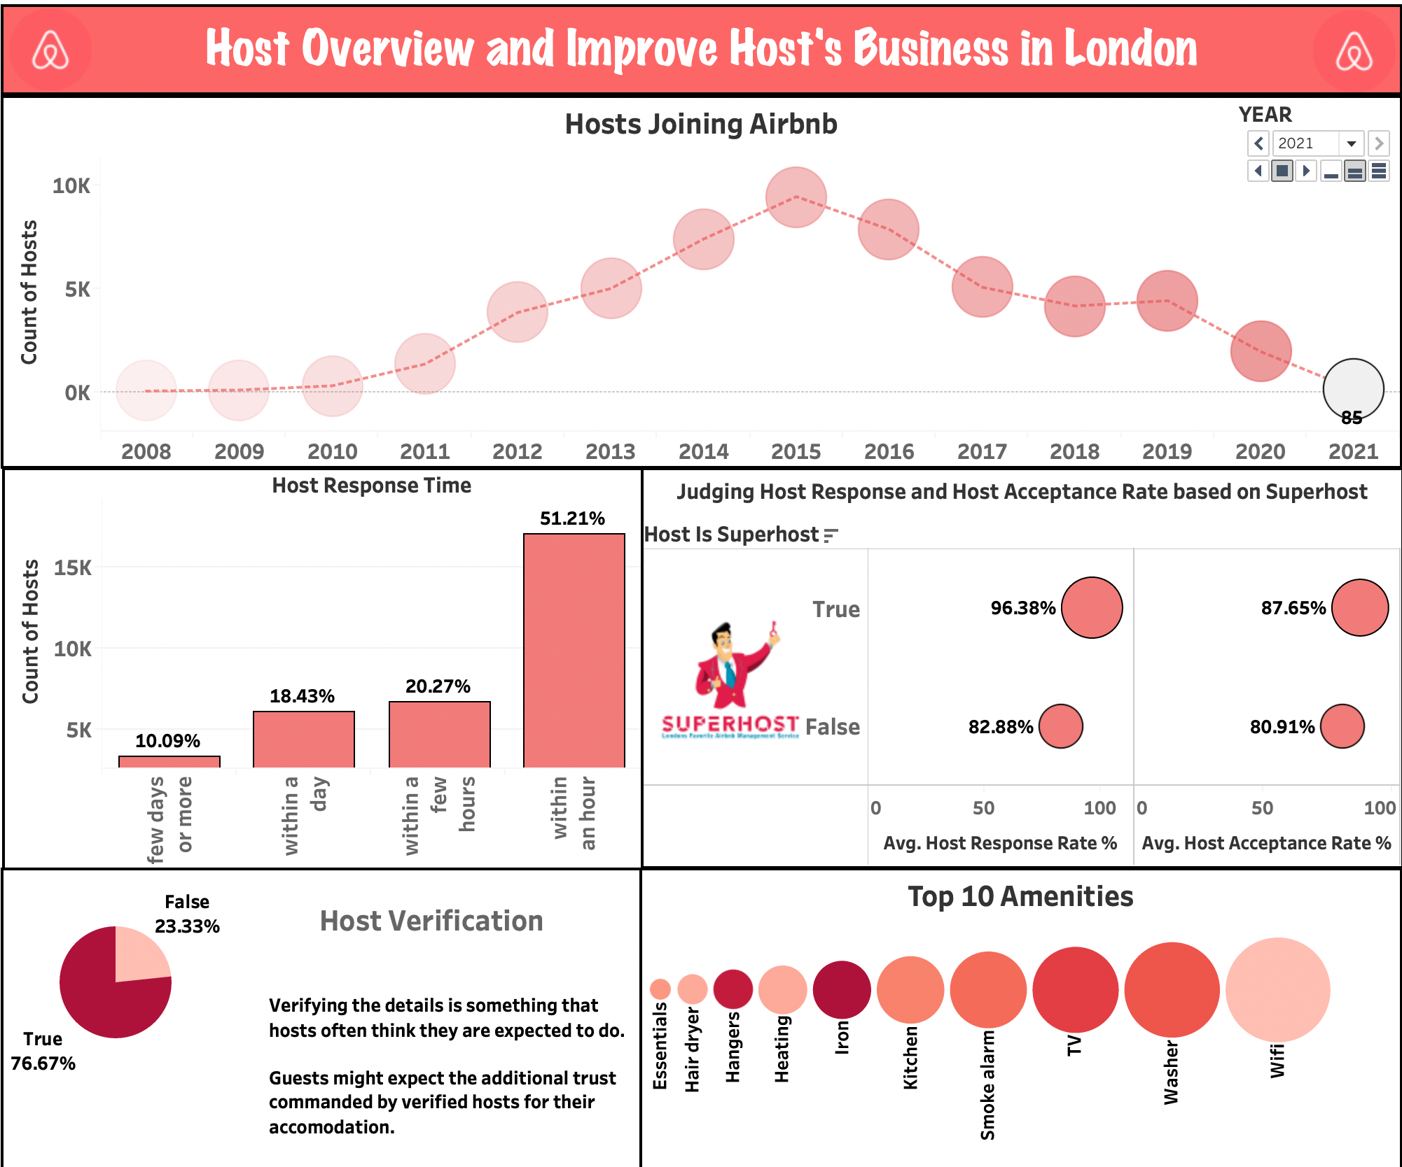



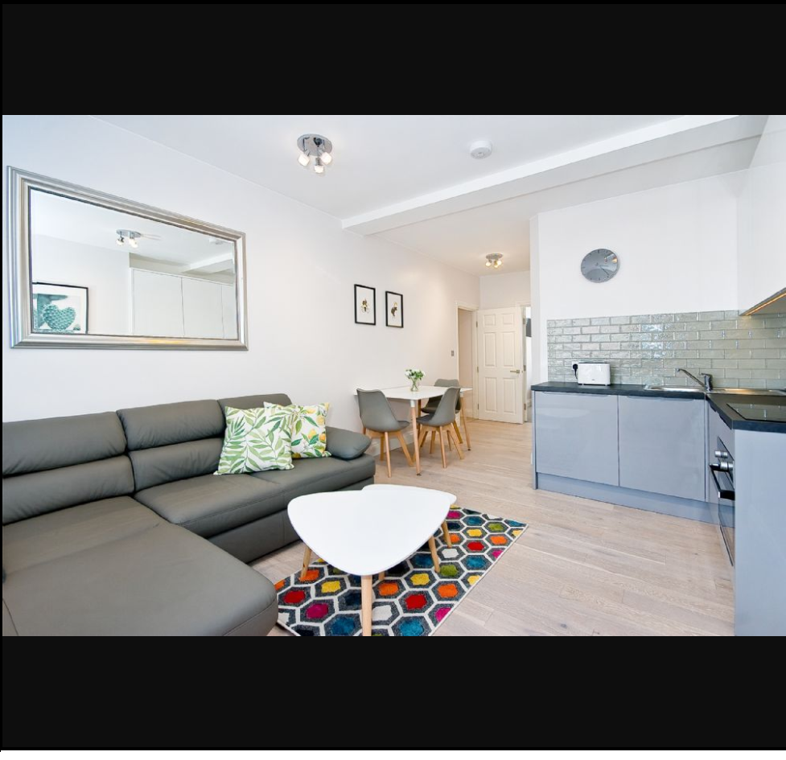

# References

<http://insideairbnb.com/get-the-data.html>